JK FLIPFOP FREQUENCY ANSWR
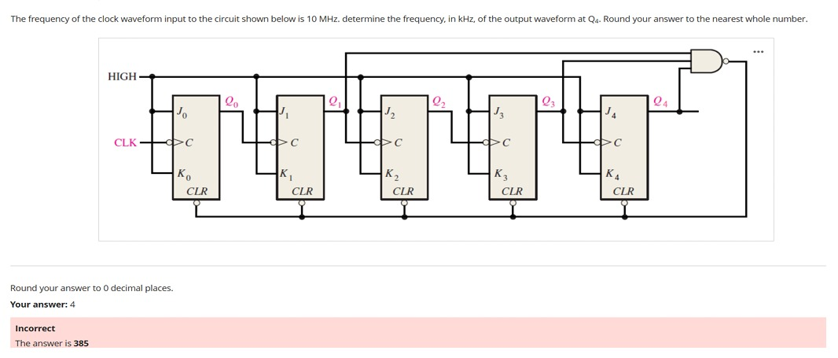
Theory
- In Synchronous operation: All flip-flops receive the same clock, eliminating ripple-delay (all outputs change together) therefore the flip flops are synchronised

- Truncated sequence
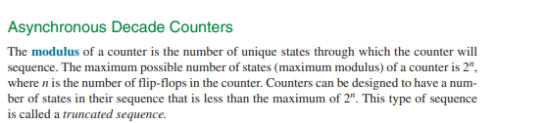
  - They also know as Modulo counters (MOD-N): These counters out up to a predefined number $N$ and then reset to Zero
  - They do not run the full $2^{n}$ states
- So they can run the full states but sometimes we change that as in make the restart earlier

- As we observe the J-K flipflop we can see a few things which is the
  - All JKs are tied J=K=1 → they toggle on every clock edge.

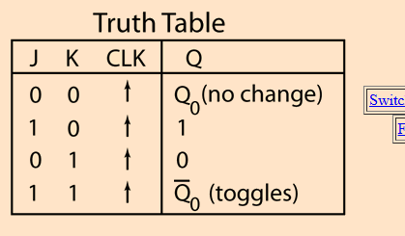
    - 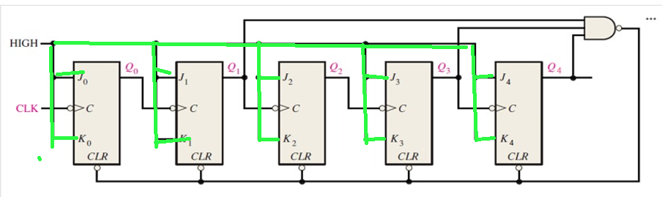

  - The CLR pin has a little bubble (small circle) at its input.
    - That bubble means the input is active-LOW.
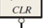
    - In simple terms to activate the clear we have to input a low which is a zero
    - This will clear the flipflops (Restart them)

  - Now look at the and gate
    - 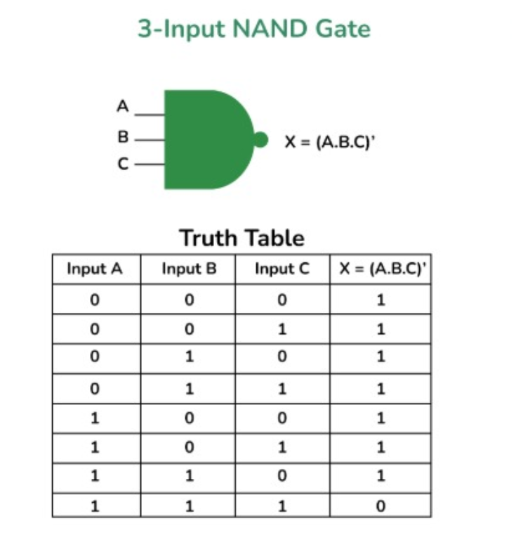
    - It only gives us a 0 when all inputs are high
    - The output of the NAND gate is connected to clear of all the flipflops
    - So at the point where the NAND gate receives all 1s then it will restart the count
    - The inputs to the gate are Q1, Q3, Q4 when all of them are one thats when the count will restart
    - To get the limit in decimal we set the all Q pins to 0 except the one connected to the NAND gate do from Q4-Q0 (MSB-LSB)
    - 11010 which is 26 in decimal that is the limit
• The counter counts from 00000 (0) up to 11001 (25)
• At 11010 (26), the AND gate activates → drives CLR LOW → all FFs reset to 0.
• This makes the counter repeat every 26 cycles.
Frequency division
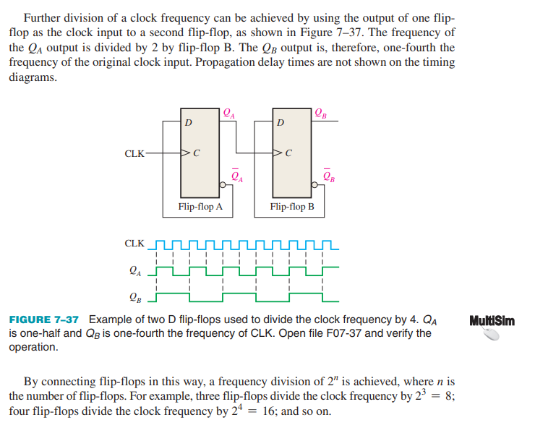
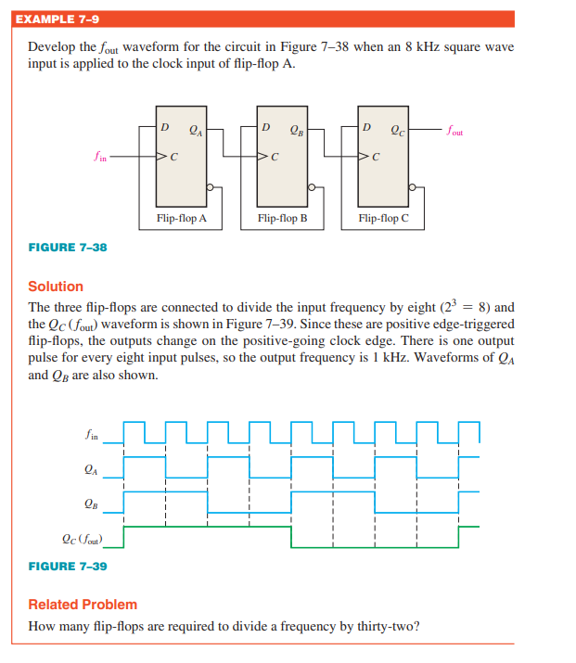
Therefore
$output frequency=\frac{ input clock}{modulus}$


ANSWER
$$outputfrequency=\frac{ input clock}{modulus}=\frac{10Mhz}{26}=384615.3846=384.615x{10}^{3}=385Khz$$

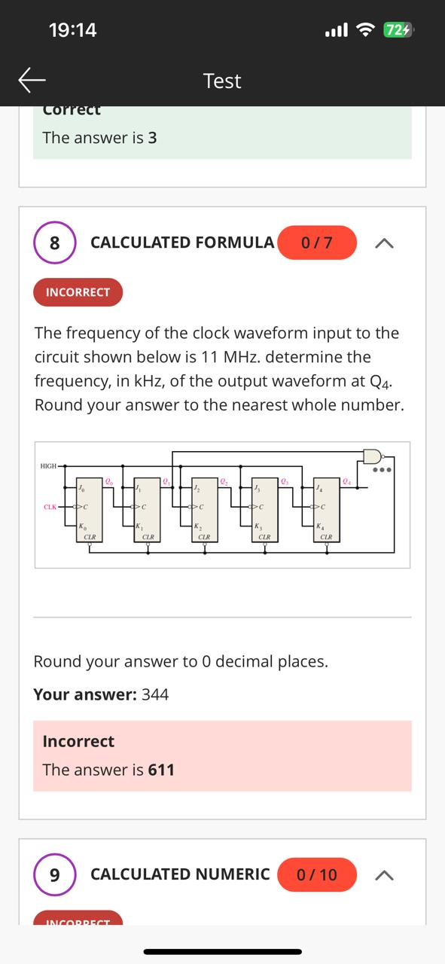
- Two input nand gate
- 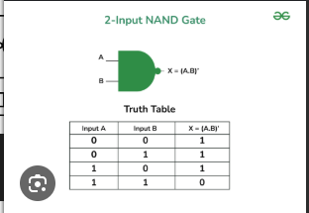
- Q1& Q4 must be 1 to clear
- MSB-LSB 10010
- DEC = 18
ANSWER
$$outputfrequency=\frac{ input clock}{modulus}=\frac{11Mhz}{18}=611111.111=611.111{10}^{3}=611Khz$$

